<Report Title>

<Student Name & Uid>

Assessment Task 2 Professional Project

Due Week 12 Friday 25 October 2019

Version <1.0>

Revision History

|  |  |  |  |
| --- | --- | --- | --- |
| **Date** | **Version** | **Description** | **Author** |
| <dd/mmm/yy> | <x.x> | <details> | <name> |
|  |  |  |  |
|  |  |  |  |
|  |  |  |  |

This document is uncontrolled when printed or downloaded from the PP2 Wattle site

Executive Summary

Include a brief summary overview (~250 words) of the project report here.

Table of Contents

1. Introduction 1

1.1 Purpose 1

1.2 POV 1

1.3 Scope 1

1.4 Definitions, Acronyms, and Abbreviations 1

2. Literature Review 2

3. Project Management 3

3.1 Team Name 3

3.2 Team Member Skill Inventory 3

3.3 Role Identification 3

3.4 Contribution 3

3.5 Team Process 3

3.6 Project Timeline 3

5. Research Methodology 5

5.1 Design Thinking 5

5.2 Empathising with the user 5

5.2.1 Research Method 5

5.2.2 Data collection 5

5.3 Recommended Improvements 5

6. Results 5

6.1 Presentation of Results 5

7. Making sense of the data 6

7.1 Discussion 6

8. Conclusions 6

9. Recommendations 6

9.1 Ideating Solutions to the Project Challenge 6

9.2 Responsible Research and Innovation 6

References 7

Appendix A Team Effectiveness Survey 8

Appendix B Meeting Minutes 10

Appendix C 11

Assessment Task 2 Professional Project

# Introduction

## Purpose

The purpose of this report is to …. *Briefly state the aim of the project and include a report outline (signposting)*

## POV

*State your POV here.*

## Scope

*Include 1-2 sentences about what was insider and outside the scope of you report and study.*

Team Number: < >

## Definitions, Acronyms, and Abbreviations

*Add any definitions, acronyms, or abbreviations commonly used in your report here.*

# Literature Review

*Briefly introduce the project task and review the relevant literature. This could include similar projects in other Australian states or countries in the world. You are encouraged to use academic sources and relevant government reports to support your ideas.*

# Project Management

## Team Name

## Team Member Skill Inventory

Outline the qualifications, skills, knowledge and experiences of each team member. Align these to EA or SFIA where possible.

## Role Identification

*What are the different roles that members of the team completed to support the project success? A table can be use to present this information. The roles can be permanently assigned or rotate. Examples include:*

* *Leader*
* *Chairperson*
* *Facilitator*
* *Scribe/Secretary*
* *Communications coordinator*
* *Resource person/Technical support*
* *Editor*
* *Reviewer*

## Contribution

Our team contributed < equally > this semester, with clear roles and responsibilities assignment and completed within the set timeframes (see also Appendix A).

## Team Process

*Briefly outline what process was used for team work – agile, waterfall, hybrid? Link this information to the literature wherever possible.*

## Project Timeline

*What were the milestones or phases in your project and the associated deadlines? Present this information in a table or present in the Appendix. Include appropriate labelling, figure/table captions and links in the main text.*

Table < >: Table title

|  |  |  |  |  |
| --- | --- | --- | --- | --- |
| Time | Phase | Activity | Responsibility | Progress |
| Row heading | Ideation | Customer Interview | xxx | Completed |
|  |  | Review | xxx | In progress |
|  |  | Team meeting | xxx | Complete |
|  | Content | Content | Content | Content |

OR Gantt Chart Sample below…

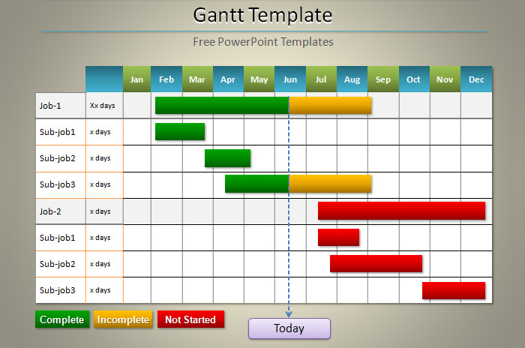

# Research Methodology

## Design Thinking

*Include a description of Design Thinking here and its relevance to the project..*

## Empathising with the user

*Include a brief description of the empathy stage of Design Thinking here.*

### Research Method

*Detail the primary (data collection procedure) and secondary research (desktop based research/literature review) that you conducted.*

### Data collection

*Detail information about what data was collected, how, when, etc. Include a copy of the survey questionnaire in the appendix and link to the main text here.*

## Recommended Improvements

*Reflect on the research methodology used for this assignment and suggest any improvements needed for future studies.*

# Results

## Presentation of Results

*Present your data visually using charts, tables or graphs. Include appropriate labelling, figure/table captions and links in the main text. Consider organising your results in relation to the POV and the project focus.*

* *The maximum speed at which the device should be able to travel*
* *What road and road related areas it is appropriate for these devices to travel on*
* *Whether there should be a limitation on who may use these devices.*
* *Other aspects?*

# Making sense of the data

## Discussion

*Discuss your qualitative and quantitative results from Section 5 above. Draw inferences in relation to the POV, and project challenge. Make links and references to the literature to show how your results are similar or different to other cases or studies. Consider discussing your results in relation to the POV and the project focus.*

*− The maximum speed at which the device should be able to travel*

*− What road and road related areas it is appropriate for these devices to travel on*

*− Whether there should be a limitation on who may use these devices.*

*− Other aspects?*

# Conclusions

*Draw general conclusions about the use of Design Thinking process and the results of your data.*

# Recommendations

## Ideating Solutions to the Project Challenge

*Based on your results and the literature, provide appropriate recommendations/ideas in relation to:*

* *The maximum speed at which the device should be able to travel*
* *What road and road related areas it is appropriate for these devices to travel on*
* *Whether there should be a limitation on who may use these devices.*
* *Other aspects?*

## Responsible Research and Innovation

*Summarise how your recommendations are ethically sound and in line with the principles of RRI.*

# References

*Insert reference list here following APA, Harvard or IEEE style guide.*

# Appendix A Team Effectiveness Survey

*Discuss and complete this section as a team.*

|  |  |  |  |  |  |
| --- | --- | --- | --- | --- | --- |
| Team Name: |  |  |  |  |  |
| Tutorial <#> / Team <#> |  |  |  |  |  |
|  | **SD** | **D** | **U** | **A** | **SA** |
| **Sense of Purpose and Commitment** |  |  |  |  |  |
| 1. We have a clear understanding of our goals |  |  |  |  |  |
| 2. We know our priorities |  |  |  |  |  |
| 3. All team members are committed to our goals |  |  |  |  |  |
|  |  |  |  |  |  |
| **Team Processes** |  |  |  |  |  |
| 4. We have effective communication processes |  |  |  |  |  |
| 5. We have effective problem solving processes |  |  |  |  |  |
| 6. We have effective decision making processes |  |  |  |  |  |
| 7. We have efficient individual accountability processes |  |  |  |  |  |
|  |  |  |  |  |  |
| **Performance Processes** |  |  |  |  |  |
| 8. We have effective processes for tracking individual performance |  |  |  |  |  |
| 9. We have effective processes for rewarding good work |  |  |  |  |  |
|  |  |  |  |  |  |
| **Team Members** |  |  |  |  |  |
| 10. Team members respect and listen to each other |  |  |  |  |  |
| 11. Team members deal with conflict constructively |  |  |  |  |  |
| 12. Team members actively participate in managing our project |  |  |  |  |  |
|  |  |  |  |  |  |
| **Creativity** |  |  |  |  |  |
| 13. We encourage divergent ideas |  |  |  |  |  |
| 14. We utilise the creative talents of individual members |  |  |  |  |  |
| 15. We brainstorm ideas together |  |  |  |  |  |
|  |  |  |  |  |  |
| **Interpersonal Relationships** |  |  |  |  |  |
| 16. I trust the members of my team |  |  |  |  |  |
| 17. We are supportive of each other |  |  |  |  |  |
| 18. Team members contribute equally |  |  |  |  |  |
| 19. We are a cohesive team |  |  |  |  |  |
|  |  |  |  |  |  |
| **Overall Effectiveness** |  |  |  |  |  |
| 20. Team grades have not suffered due to poor teamwork |  |  |  |  |  |

|  |  |  |
| --- | --- | --- |
| **Key** | | |
| **SD** |  | Strongly Disagree |
| **D** |  | Disagree |
| **U** |  | Uncertain |
| **A** |  | Agree |
| **SA** |  | Strongly Agree |

Team Effectiveness Evaluation

*Assess yourself and your team members’ contribution to the achievement and completion of the professional project. Complete only the fields needed to represent the number of people in your team.*

|  |  |  |  |  |  |
| --- | --- | --- | --- | --- | --- |
| **Name and ANU Id of Team Member:** | **HD** | **D** | **CR** | **P** | **F** |
| 1. Self *(you)* |  |  |  |  |  |
| 2. |  |  |  |  |  |
| 3. |  |  |  |  |  |
| 4. |  |  |  |  |  |
| 5. |  |  |  |  |  |
| **Member** | **Self** | **2** | **3** | **4** | **5** |
| **Contribution to professional project team outcomes** | **Percentage ( % ) of contribution (total 100%)** | | | | |
| Group Pitch |  |  |  |  |  |
| Project Report |  |  |  |  |  |
| Meeting Minutes |  |  |  |  |  |

# Appendix B Meeting Minutes

*Include one copy of your meeting minutes here (max 2 pages) Follow the structure outlined on Wattle the presentation of the minutes.*

# Appendix C

*Add additional appendices here. Appendices are not included in the word count. One appendix per page or section. Appendices are labelled alphabetically.*